**Azure AI Inference SDK** and the **OpenAI SDK** both allow you to interact with AI models like GPT, but they are designed for **different platforms** and offer **different capabilities** based on the hosting and billing models.

Here's a breakdown of the **key differences**:

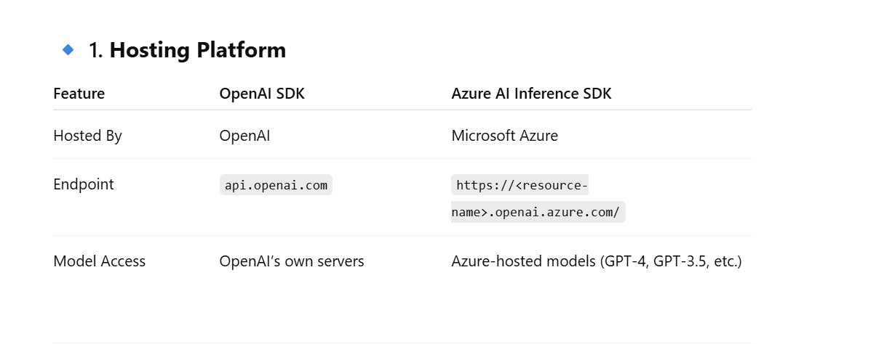

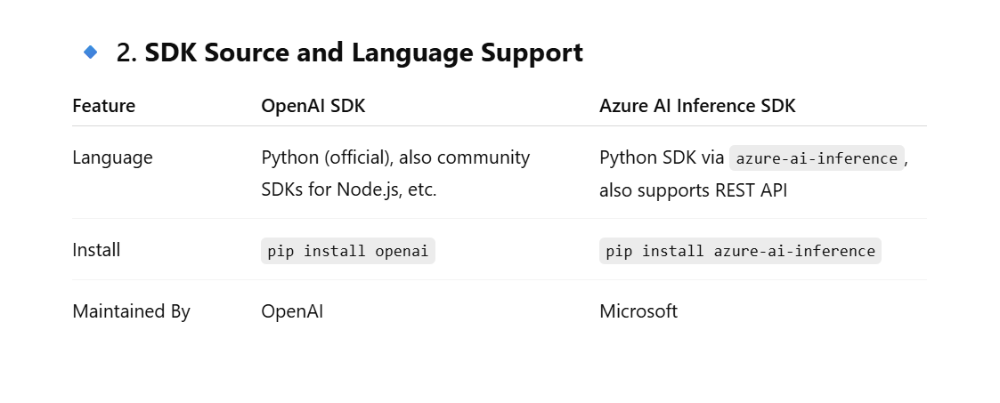

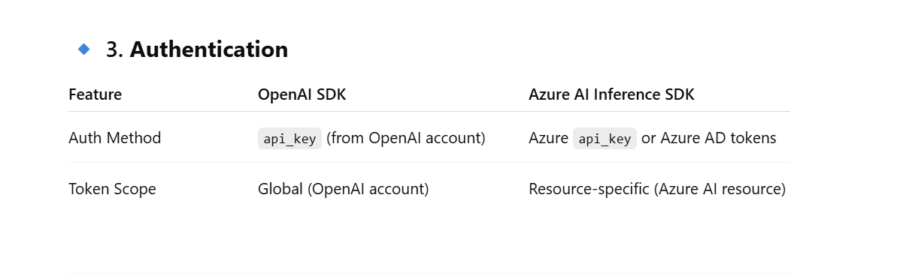

In GitHub Copilot or GitHub Codespaces or other GitHub-integrated AI features, you may see:

* gpt-4.1 as a **model option**
* Two **available SDKs** for it: **OpenAI SDK** and **Azure AI Inference SDK**

**✔️ Reason:**

Because **GPT-4.1 is available via both Azure OpenAI and OpenAI**, GitHub allows you to choose your preferred provider. Depending on your access credentials and organizational preferences:

* **Enterprise customers** may prefer Azure for compliance, security, or billing
* **Developers** might use OpenAI SDK for simplicity or personal projects

Both SDKs point to the **same underlying GPT-4.1 model**, but through **different cloud providers**.

|  |
| --- |
| **Which should I use?** |

|  |
| --- |
| Depends on where you have access: use Azure if you have an Azure subscription, otherwise OpenAI SDK is simpler |